Problem Statement

You are working as a DevOps Engineer in a company named Sanders & Fresco Pvt ltd. You have been asked by your manager to create a Maven Project using Jenkins and build a war file of that project. As a proof of concept, you have been given a web application to buil

d. And once done with building the war file, deploy it over the tomcat server.

Steps to solve:

Open Jenkins and create a Maven project using it.

You will have to create the following jobs, which are as follows:

* Compile
* Code Review
* Unit test
* Package
* Deploy

You have to complete your job within the given time frame.

Solutions :

1. Jenkins + maven integration: (one-time process to run the maven project on Jenkins)
   1. Go to Jenkins -----> manage Jenkins -----> Global Tool configuration
   2. Automatically set up Maven
   3. Go down to the section where we add the Maven

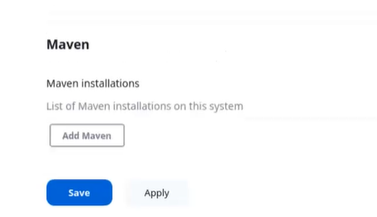

* 1. Give the name of the tool and remember it (use in the pipeline) and the latest version
  2. And save it. Jenkins installs it automatically
  3. To check the maven installation /var/lib/Jenkins directory where you get the maven directory

1. Create a job for the maven project using the option pipeline
2. In the configure-> advance project option add the Pipeline script from the dropdown

pipeline{

tools{

maven 'mymaven'

}

agent any

stages{

stage('Clone a Repo'){

steps{

git 'https://github.com/Sonal0409/DevOpsCodeDemo.git'

}

}

stage('Compile the code'){

steps{

sh 'mvn compile'

}

}

stage('CodeReview'){

steps{

sh 'mvn pmd:pmd'

}

}

stage('Unit Test'){

steps{

sh 'mvn test'

}

}

stage('Package'){

steps{

sh 'mvn package'

}

}

1. Save the script and build the project

